CST8921 – Cloud Industry Trends
  - Lab 2 – Cloud Security trends

Introduction
In this lab, students will explore and understand the criticality of cloud security in industries. A crucial component of cloud security is focused on protecting data and business content, such as customer orders, secret design documents, and financial records. Preventing leaks and data theft is critical for maintaining your customers’ trust and protecting the assets that contribute to your competitive advantage. Cloud security's ability to guard your data and assets makes it crucial to any company switching to the cloud.
Cloud security ensures your data and applications are readily available to authorized users. You'll always have a reliable method to access your cloud applications and information, helping you quickly act on any potential security issues.

Objective
The goal of this lab activity is to familiarize students with the concepts, techniques and use cases of cloud security using AWS/Azure/GCP

Prerequisites:
- Basic understanding of cloud security concepts
- A computer with internet access
- Windows or mac machine
- Web browser
- Cloud portal access with any cloud service providers (AWS, Azure, GCP)
Lab Activity Overview:

Task 1: Create an Azure Policy – Allowed Locations
Purpose: Ensure resources can only be deployed in an approved region.

Steps:
- Sign in to the Azure Portal
- Search for Policy
- Select Definitions
- Search for the built-in policy:
  - “Allowed locations”
- Select the policy → Click Assign
- Configure:
  - Scope: Subscription
  - Allowed locations: Canada Central
- Review + Create

Validation:
- Attempt to create a resource in a different region (e.g., East US)
- Confirm deployment fails

Task 2: Create a Virtual Network (Canada Central)
Purpose: Establish a secure network boundary.

Steps:
- Search for Virtual Networks
- Select Create
- Configure:
  - Region: Canada Central
  - Address space: 10.0.0.0/16
- Do not add subnets yet
- Review + Create

Task 3: Create Subnets & Enable Storage Service Endpoint
Purpose: Ensure storage traffic stays within Azure’s backbone network.

Subnets to Create:
Subnet Name | Address Range | Purpose
private-subnet | 10.0.1.0/24 | Secure access
public-subnet | 10.0.2.0/24 | Internet-facing

Steps:
- Open the Virtual Network
- Go to Subnets
- Add private-subnet
  - Enable Service Endpoint
  - Service: Microsoft.Storage
- Add public-subnet (no service endpoint)
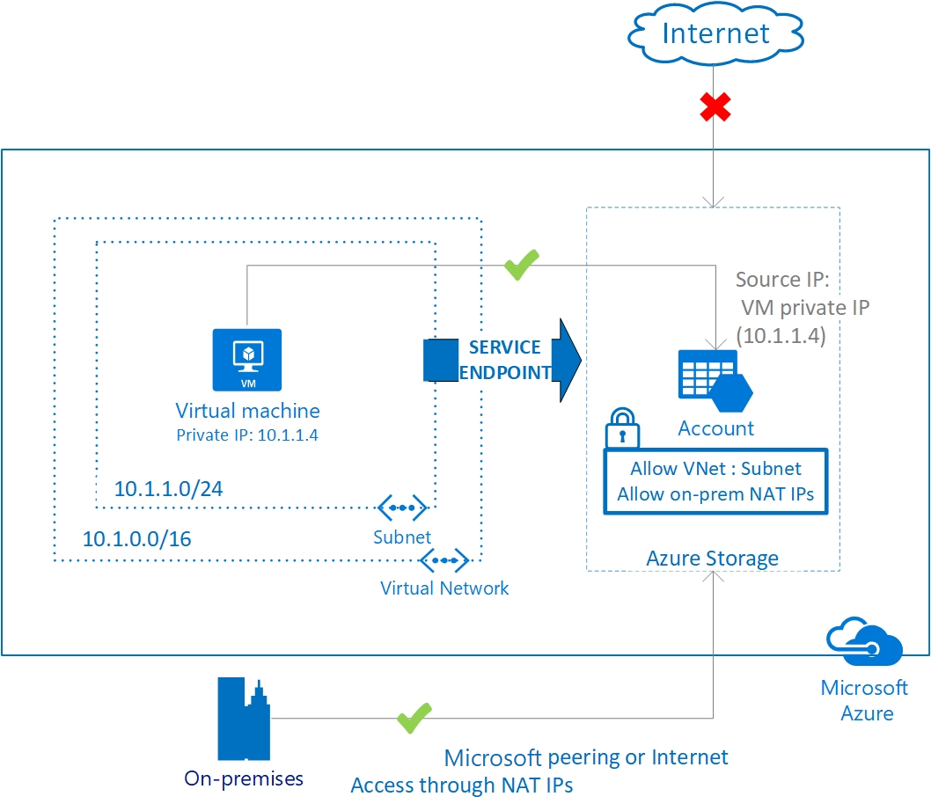
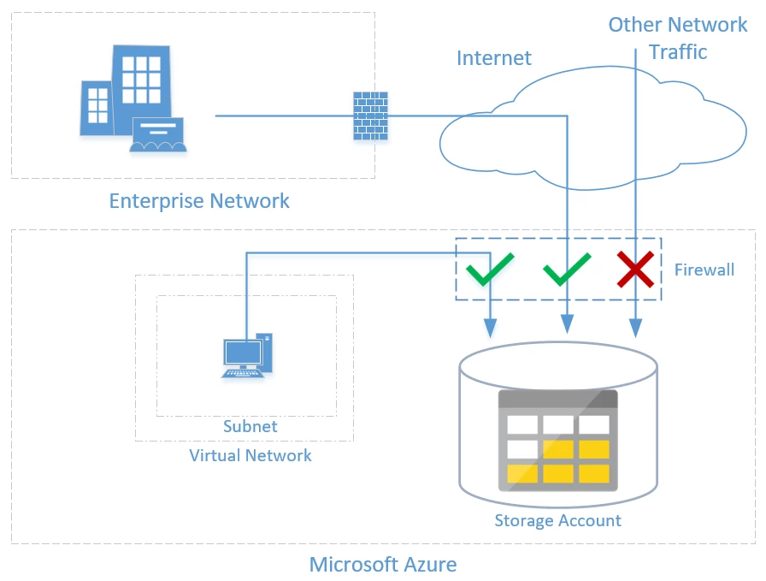

Task 4: Create Network Security Group (NSG)
Purpose: Control inbound and outbound network traffic.

Steps:
- Search for Network Security Groups
- Create NSG in Canada Central
- Associate NSG to private-subnet

Task 5: Configure NSG Rules (Private Subnet)

Outbound Rule – Allow Azure Storage
- Destination: Service Tag
- Service Tag: Storage
- Action: Allow
- Priority: 100

Outbound Rule – Deny Internet Access
- Destination: Internet
- Action: Deny
- Priority: 200

Task 6: Configure NSG for Public Subnet (RDP Access)

Inbound Rule – Allow RDP
- Source: Any
- Port: 3389
- Protocol: TCP

Task 7: Create a Storage Account with File Share
Purpose: Secure storage access to only approved subnets.

Steps:
- Create Storage Account
  - Region: Canada Central
- Go to Networking
- Set:
  - Network access: Enabled from selected networks
  - Allow access only from private-subnet
- Create Azure File Share

Task 8: Deploy Virtual Machines
Deploy two Windows VMs:
VM Name | Subnet
vm-private | private-subnet
vm-public | public-subnet
- Enable Azure Bastion
- Use same credentials for both VMs
📸 Screenshot required: VM overview pages

Task 9: Test Storage Access from Private Subnet (Allowed)
- Connect to vm-private using Bastion
- Open Windows PowerShell
- Run the following command:
$key = @{
String = "<storage-account-key>"
}
$acctKey = ConvertTo-SecureString @key -AsPlainText -Force

$cred = @{
ArgumentList = "Azure\<storage-account-name>", $acctKey
}
$credential = New-Object System.Management.Automation.PSCredential @cred

$map = @{
Name = "Z"
PSProvider = "FileSystem"
Root = "\\<storage-account-name>.file.core.windows.net\file-share"
Credential = $credential
}
New-PSDrive @map
Expected Result:
Azure file share successfully mapped to drive Z:

Task 10: Test Storage Access from Public Subnet (Denied)
- Connect to vm-public
- Repeat the same PowerShell command
Expected Result:
Access denied error

6. Validation Summary
Scenario | Expected Outcome
Resource creation outside Canada Central | Blocked
Storage access from private subnet | Allowed
Storage access from public subnet | Denied

7. Cleanup (Mandatory)
To avoid unexpected costs:
- Delete:
  - Virtual Machines
  - Storage Account
  - NSGs
  - Virtual Network
  - Azure Policy assignment

8. Deliverables & Grading

Lab Report Requirements:
- Step-by-step explanation
- Screenshots for each task
- Security analysis and observations
- Validation results
- Cleanup confirmation

Submission:
- Upload report to Brightspace → Assignments

Important Notes:
For grading prepare a lab report with your findings and analysis and share that in an Assignments tab in Brightspace.

